**DBMS PROJECT**

**On**

**Airline Reservation system**

**Submitted By –**

**Shivansh Bhardwaj**

**2017UCP1515**

**Acknowledgement**

**This is a certified work done by Shivansh Bhardwaj under the guidance of Prof. Namita Mittal.**

**Tools Used :-**

**Front-End=HTML,CSS,JS,Bootstrap**

**Back-End=PHP,Mysql**

**Sources Used:**

**wikipedia,w3schoos,geeksforgeeks,google flights,stackoverflow**

**About Project**

**A demo WebSite of Airline Reservation System with Customer and Admin login with many features as Create_User,Forgot_password**

**Customer Can:**

* + **Book Flight Tickets for a particular date between selected cities**
  + **View booked tickets**
  + **Cancel booked Tickets**

**Admin Can:**

* + **Add new jet**
  + **Add new flight**
  + **Cancel a flight**
  + **View booked ticket Statistics**

**Modules Used In the Project :**

customer_homepage.php

Displays the customer dashboard after customer login

admin_homepage.php

Displays the admin dashboard after admin login

login_handler.php

Authenticate valid user by username and password by matching from customer table and start session if success

logout_handler.php

Logout a user by ending the session

new_user_form_handler.php

Registers a new user by taking input all the necessary details and inserting them into customer table

book_tickets.php

Inputs the flight requirements from user such as departure and arrival details and number of passengers and redirects to view_flights_form_handler

view_flights_form_handler.php

Displays all the flights that meets the user requirements. User select a flight for booking and redirects to book_tickets2.php.Prices are Dynamic.

book_tickets2.php

User is required to enter all the required details for ticket booking such as passenger names, age and choice of meal.

add_ticket_details_form_handler.php

It processes all the passengers information and redirects user to payment page.

payment_details.php

It displays all the payment modes and amount to be paid.

payment_details_form_handler.php

It handles the payment and if payment is success, redirects to ticket_success page.

ticket_success.php

It displays that ticket is successfully booked.

forgot_pass_handler.php

It handles the forgot password request and redirects user to window where he can create new password only if details given by user are verified.

view_booked_tickets.php

It helps the user to view tickets from tickets table in database having the given cust. id

cancel_booked_tickets.php

It helps the user to cancel the tickets booked having the provided pnr number by customer.

add_flight_details_form_handler.php

It helps the admin to add new flight into the flight_details table with the help of jet_id.

add_jet_details_form_handler.php

It helps the admin to enter details of a new jet and give it a unique jet_id

view_booked_tickets_statistics_form_handler.php

It helps the admin to view number of tickets booked for a particular day

by querying into ticket_details table.

activate_jet_details.php and deactivate_jetdet.php

Admin can activate and deactivate a jet so that it can be used to schedule a flight or not

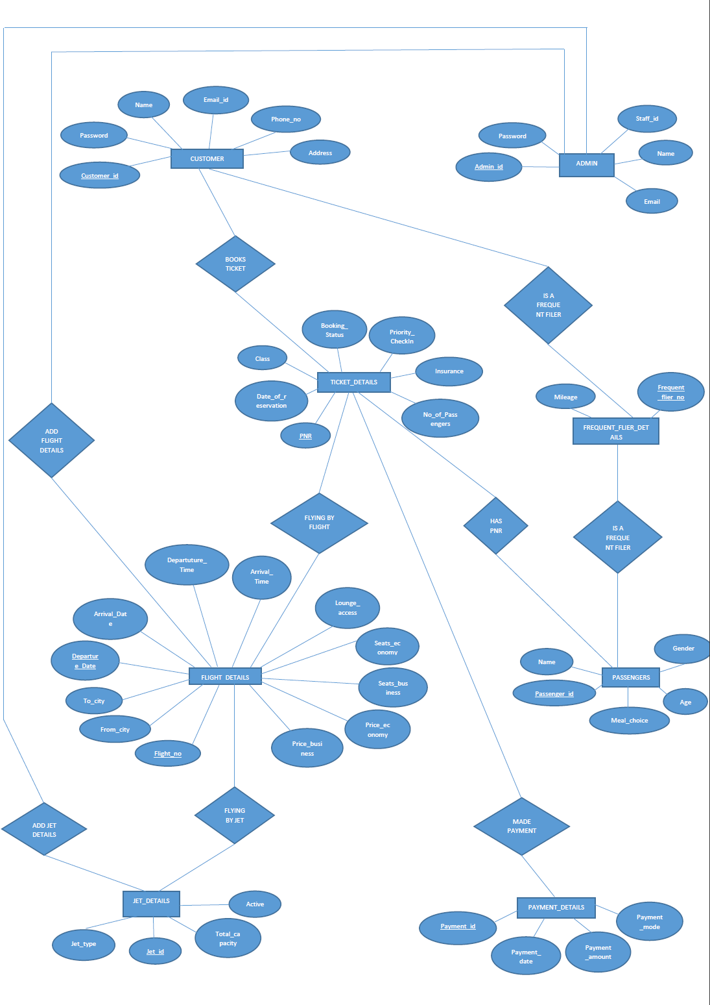

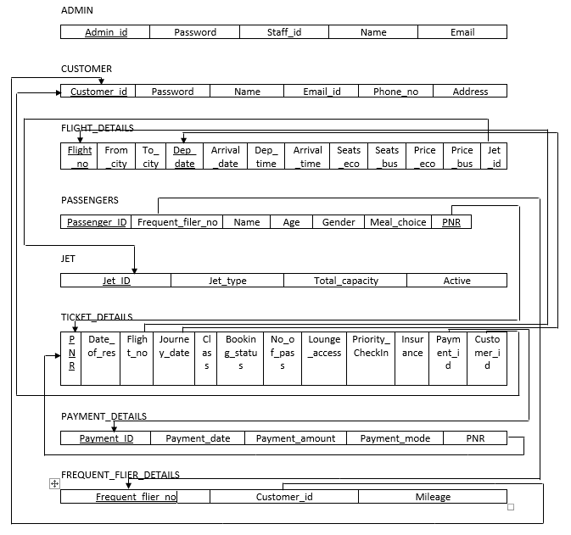

**Functional Dependencies :-**

**Customer**

customer_id->

pwd,name,email,phone_no,address

Bcnf Form

**Admin**

admin_id->

pwd_type,staff_id,name,email

Bcnf Form

**Jet_details**

jet_id->

jet_type,jet_type,total_capacity,active

Bcnf Form

**Flight_details**

flight_no,departure_date->

from_city,to_city,arrival_date,departure_time,arrival_time,seats_economy,seats_business,price_economy,price_business,jet_id

Bcnf Form

**Ticket Details**

**pnr**->

date_of_reservation,flight_no,journey_date,class,booking_status,no_of_passengers,lounge_access,priority_checkin,insurance,payment_id,customer_id

Bcnf Form

**Payment_details**

**payment_id**->

pnr,payment_date,payment_date,payment_amount,payment_mode

Bcnf Form

**Passengers**

**passenger_id,pnr->**

**name**,age,gender,meal_choice,frequent_flier_nos

Bcnf Form

**Frequent_flier_details**

**frequent_flier_no->**

customer_id,mileage

Bcnf Form